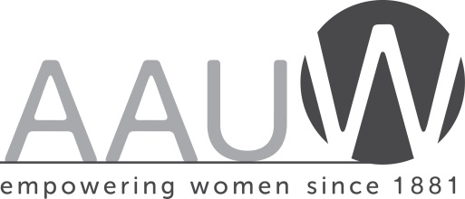

For Immediate Release Contact: Karen Hayes
January 17, 2022 E-mail address: karent.hayes@gmail.com
Phone # - 904-679-5329

Human Trafficking Awareness
Emphasized by AAUW St. Augustine

The AAUW St. Augustine Branch is working with St. Johns County Board of County Commissioners, St. Augustine Beach and St. Augustine City Commissions to raise human trafficking awareness. All three legislative bodies have issued proclamations to make January 2022 be Human Trafficking Awareness Month. The Betty Griffin Center also collaborated with AAUW St. Augustine on these proclamations.
The St John’s County proclamation was accepted by Kristi Pierce, Co-President of AAUW St. Augustine on Dec. 21. Cathie Altman accepted the proclamation from St. Augustine Beach on January 10, and Kathy Marquis received the proclamation sponsored by AAUW member and Councilwoman Barbara Blonder from St. Augustine on January 10.
Karen Zalkin, AAUW St. Augustine Director of Public Policy, reports that Florida is the third highest human trafficking state in the country and since 2007 has had over 7,000 victims. AAUW Florida is advocating for bills in the FL legislature to increase awareness and help survivors. The local branch is researching ways to help remedy the situation.
Zalkin states: “Make no mistake about this, it is not immigrants or people in shipping containers we are talking about. It is women and young girls, but also boys and young men who are our neighbors who get sucked in. It is hard to get out and those survivors, who do, fight a tremendous battle to sever relationships with their traffickers who may be giving them things they were never able to get on their own. This is a complex problem.”
For more information about AAUW St. Augustine, contact Maxine Burns, Director of Membership, at mmmburns@yahoo.com, or learn more at staugustine-fl.aauw.net, and on Facebook, AAUW St. Augustine.

